**🔖 Project Title:**

**Sales Analytics Dashboard with Power BI**

**📌 Objective:**

The primary goal of this project is to create a dynamic and interactive Power BI dashboard that provides comprehensive insights into **sales performance**, **customer behavior**, and **product-wise trends** for an e-commerce business. This dashboard supports data-driven decision-making by enabling stakeholders to analyze sales, monitor KPIs, and identify top-performing areas.

**📁 Dataset Description:**

* **Sales Data**: Monthly transactional data for products.
* **Customer Data**: City-wise customer purchase details.
* **Product Data**: Product category, sub-category, and item-level sales.
* **Budget Data**: Monthly targets to compare against actual performance.

**🛠️ Tools & Technologies Used:**

* **Power BI Desktop**
* **DAX (Data Analysis Expressions)**
* **Map Visuals (Bing Maps Integration)**

**📈 Dashboard Pages & Features:**

**1. Sales Overview Page**

* **Sales vs Budget Card** – Highlights total sales (1,046,023) vs the monthly target (1,000,000) with a visual indicator of performance.
* **Sales by Product Category** – Donut chart showing category-wise breakdown (e.g., Bikes ~92.63%, Accessories ~4.94%).
* **Top 10 Customers** – Bar chart displaying highest-value customers.
* **Top 10 Products** – Bar chart of best-selling products (e.g., Mountain Bikes).
* **Map View of Sales by City** – Interactive map showing geographic distribution of customer orders.
* **Sales and Budget by Month** – Monthly trend comparison between actual sales and budget.

**2. Customer Details Page**

* **Total Sales & Budget** – Cumulative summary (e.g., ₹1,63,51,550 sales vs ₹1,53,00,000 budget).
* **Monthly Sales Trend** – Line graph to monitor performance across the year.
* **City-wise Sales Map** – Visual representation of customer cities.
* **Top Customers** – Chart of highest spenders (e.g., Jordan Turner, Maurice Shan).
* **Customer-wise Monthly Sales Table** – Detailed matrix showing each customer’s monthly purchases.

**3. Product Details Page**

* **Product Category-wise Sales Table** – Monthly performance of each product.
* **Sales Trend by Month** – Same as above, with product focus.
* **City Map for Product Sales** – Where products are performing best geographically.
* **Top 10 Products** – Highest revenue-generating items like Mountain-200 Black and Road-250 Red.

**🧠 Insights & Learnings:**

* Mountain bike categories dominate the sales revenue.
* Customer concentration is high in certain regions (California, Texas, etc.).
* Budget goals were met/exceeded in most months, indicating strong performance.
* A small group of customers contributes significantly to revenue (Pareto Principle).

**📌 Key DAX Measures:**

* Total Sales = SUM(Sales[Amount])
* Total Budget = SUM(Budget[Target])
* Variance = [Total Sales] - [Total Budget]
* Sales % of Budget = DIVIDE([Total Sales], [Total Budget], 0)

**💡 Features Used:**

* Slicers for **Year**, **Month**, **Customer City**, **Product Name**, **Category**, and **Sub Category**
* Drill-down capabilities in tables and visuals.
* Custom tooltips for enhanced interaction.
* Conditional formatting in matrices.
* KPI indicators with up/down arrows for performance tracking.

**DASHBOARD:**

Page -1

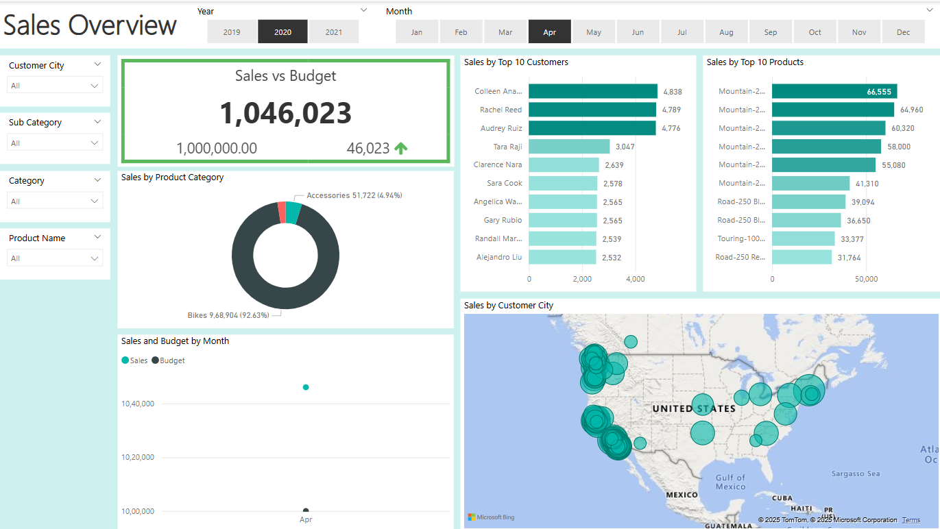

Page -2

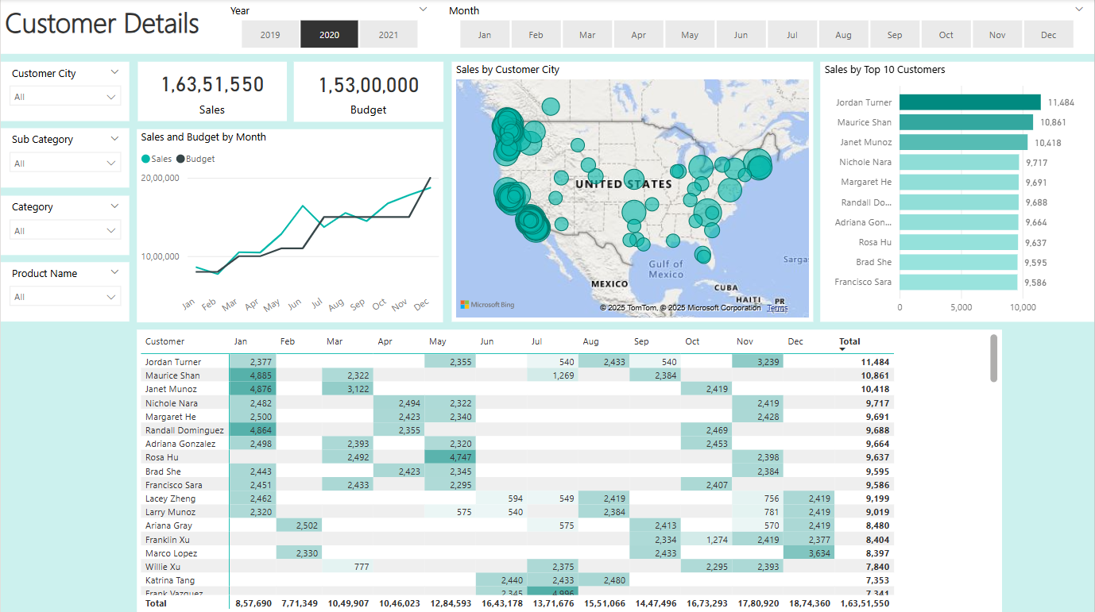

Page -3

